AI

|  |  |  |  |  |  |  |  |  |
| --- | --- | --- | --- | --- | --- | --- | --- | --- |
|  | | | | | | | | |
|  | | CSPC53-Computer Networks  Theory - Project Report | | | | | |  |
|  |  | | | | | |  | |
|  | | | | Group 17 |  | | | |
|  | | | | Roll Numbers106119112 106119100 Group MembersSATYARTH PANDEY RAJNEESH PANDEY SectionCSE-B |  | | | |
|  | | |  | | |  | | |

Workflow Diagram

Simulation Environment

Jupyter notebook (python) and CSV files (databases) with IP addresses

Our simulation is devoted to determining the performance of the proposed ad hoc pivot hashing on practical performance indicators. This paper looks at two important performance indicators: maximal search length (MSL) and average search length (ASL).

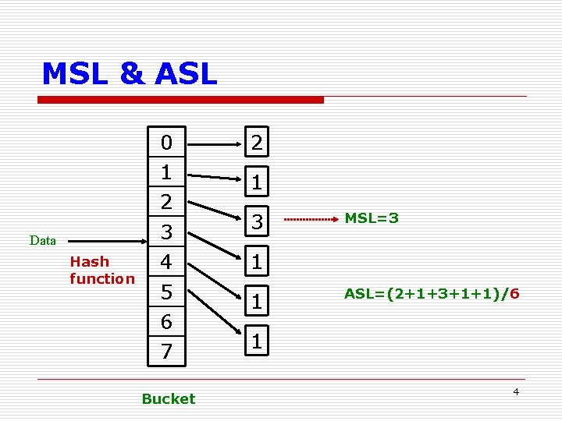

The above fig shows a graphical example of the performance indicators. The indicator MSL denotes the maximum number of hash collisions which in turn indicates the maximal number of search steps required to search through the collision. ASL reflects the average number of lookups needed to find an item in the database.

Results ( Table, Graph)

Comparison of MSL and ASL values between proposed and existing Algorithms on across multiple databases on :

1*) Real IP Addresses :*

2*) Artificial IP Addresses:*

Performance Comparison Graphs with previously Well-Known Algorithms :

1) On Real IP Addresses

2) On Artificial IP Addresses

Resultant *d* value on XORing and Percentage reduction Graphs

Possible Extensions

Concept Extension :

The distribution of data in a wide range of applications requires new research in hashing. Many applications such as IP address lookup, intrusion detection systems, general database query and string matching can benefit from hashing algorithms designed for an arbitrary distributed database. The proposed methodology of ad hoc pivot hashing demonstrates that improvement in overall performance can be achieved by carefully adapting to the distribution of the application. The ad hoc pivot hashing delivers several critical insights into new areas of hashing research. A potential expansion to hashing includes further exploring the database by investigating correlation among bit vectors for even better decision on how and which bits to be XORed. Other extensions include finding a non-exclusive XORing hashing in which bits are reused to further improve the search performance.

Extension on Data structure :

Instead of using Linear data structure, We can use Balanced Binary Search Tree such as Red Black Tree, AVL Tree etc. to store the Key (Hashed Value of IP Address ) & Value(IP Address/Other Networking Info.) pairs .

*Base Paper :

<https://ieeexplore.ieee.org/document/4087686>

*Real IP Address Database source :

<https://datahub.io/core/geoip2-ipv4>

*Artificial IP Address Database source :

<https://www.ipvoid.com/random-ip/>